**Module 3 Activity 1: Database Access**

Tahaylia A Higgins

Arizona State University

IFT 458: Middleware Prog & Database Sec

Dinesh Sthapit

September 24, 2023

**Module 3 Activity 1: Database Access**

This paper serves to demonstrate how to setup an MS SQL server in vscode, how to create a Node.js MSSQL App, and query database.

# Setting up a MS SQL Server

*Note.* Downloading the MS SQL server from Vscode extension. From Personal VS code by Tahaylia Higgins, 2023.

*Note.* MS SQL Server is installed. From Personal VS code by Tahaylia Higgins, 2023.

*Note.* Select MS SQL: Connect from the command palette. From Personal VS code by Tahaylia Higgins, 2023.

*Note.* Select MS SQL Manage Connection Profiles. From Personal VS code by Tahaylia Higgins, 2023.

*Note.* Select Create. From Personal VS code by Tahaylia Higgins, 2023.

*Note.* Typed in the server name provided for us. From Personal VS code by Tahaylia Higgins, 2023.

*Note.* Typed in the database name provided for us.. From Personal VS code by Tahaylia Higgins, 2023.

*Note.* Typed in the authentication type provided for us. From Personal VS code by Tahaylia Higgins, 2023.

*Note.* Typed in the username provided for us. From Personal VS code by Tahaylia Higgins, 2023.

*Note.* Typed in the password provided for us. From Personal VS code by Tahaylia Higgins, 2023.

*Note.* Saved the password. From Personal VS code by Tahaylia Higgins, 2023.

*Note.* Created a Profile Name. From Personal VS code by Tahaylia Higgins, 2023.

*Note.* Showed proof of installations by creating a SELECT Statement to query the data for one of the tables in the SQL Server. From Personal VS code by Tahaylia Higgins, 2023.

*Note.* Output of the query above. From Personal VS code by Tahaylia Higgins, 2023.

Node.js MSSQL App

*Note.* Created a new folder in vscode. From Personal VS code by Tahaylia Higgins, 2023.

*Note.* Initializing node.js project with the data provided for us. From Personal VS code by Tahaylia Higgins, 2023.

*Note.* Ran the command provided for us to install the requird dependencies. From Personal VS code by Tahaylia Higgins, 2023.

*Note.* Created an app.js file and transferred the code from the instructions. From Personal VS code by Tahaylia Higgins, 2023.

*Note.* Created an server.js file and transferred the code from the instructions. From Personal VS code by Tahaylia Higgins, 2023.

*Note.* Created a test GET route. From Personal VS code by Tahaylia Higgins, 2023.

*Note.* Created an config.env file and transferred the code from the instructions. Note, the port was later changed to 6001, as seen in other codes below. From Personal VS code by Tahaylia Higgins, 2023.

*Note.* Created a db.config.js file. From Personal VS code by Tahaylia Higgins, 2023.

*Note.* Transferred the code to the db.config.js file from the instructions. From Personal VS code by Tahaylia Higgins, 2023.

*Note.* Created a new file called db.manager.js and transferred the code from the instructions. From Personal VS code by Tahaylia Higgins, 2023.

*Note.* Created a routes folder, added a new file called salesRouter.js and transferred the code from the instructions. From Personal VS code by Tahaylia Higgins, 2023.

*Note.* Added a new file called userRoutes.js to the routes folder and wrote the appropriate code. From Personal VS code by Tahaylia Higgins, 2023.

*Note.* Created a controllers’ folder, added a new file called salesController.js and transferred the code from the instructions From Personal VS code by Tahaylia Higgins, 2023.

*Note.* Added a new file called userControllers.js to the controllers’ folder and wrote the appropriate code. From Personal VS code by Tahaylia Higgins, 2023.

*Note.* Refactored db.manager.js code to be more concise, and implemented try-catch statements. From Personal VS code by Tahaylia Higgins, 2023.

*Note.* Refactored db.manager.js code to be more concise, and also implemented try-catch statements. From Personal VS code by Tahaylia Higgins, 2023.

*Note.* Ran server on new port 6001. From Personal VS code by Tahaylia Higgins, 2023.

*Note.* Retrieved sales data via GET route in Postman. From Personal VS code by Tahaylia Higgins, 2023.

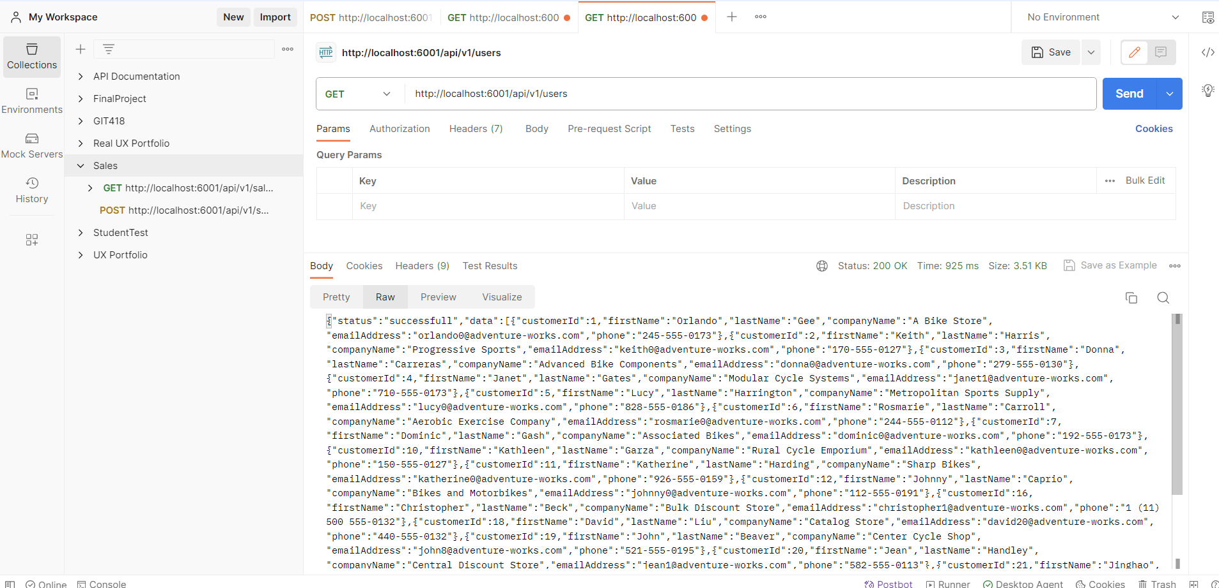

*Note.* Performed a test to retrieve users data via GET route in Postman. From Personal VS code by Tahaylia Higgins, 2023.

*Note.* Created a new sales product using POST route. This is the response for POST route. The new sales product cannot be added to the list of other products or be retrieved via GET route because we do not have administrative access to AdventureWorks database to manipulate the data. From Personal VS code by Tahaylia Higgins, 2023.

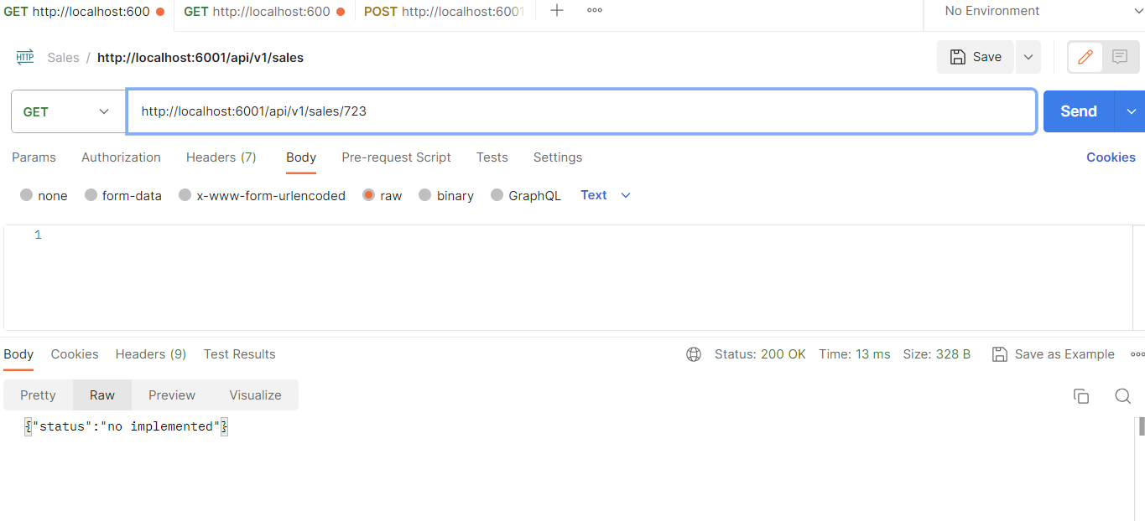

*Note.* Received sales product by id response for POST route. This is the response status since we do not have administrative access to AdventureWorks database to manipulate the data. From Personal VS code by Tahaylia Higgins, 2023.

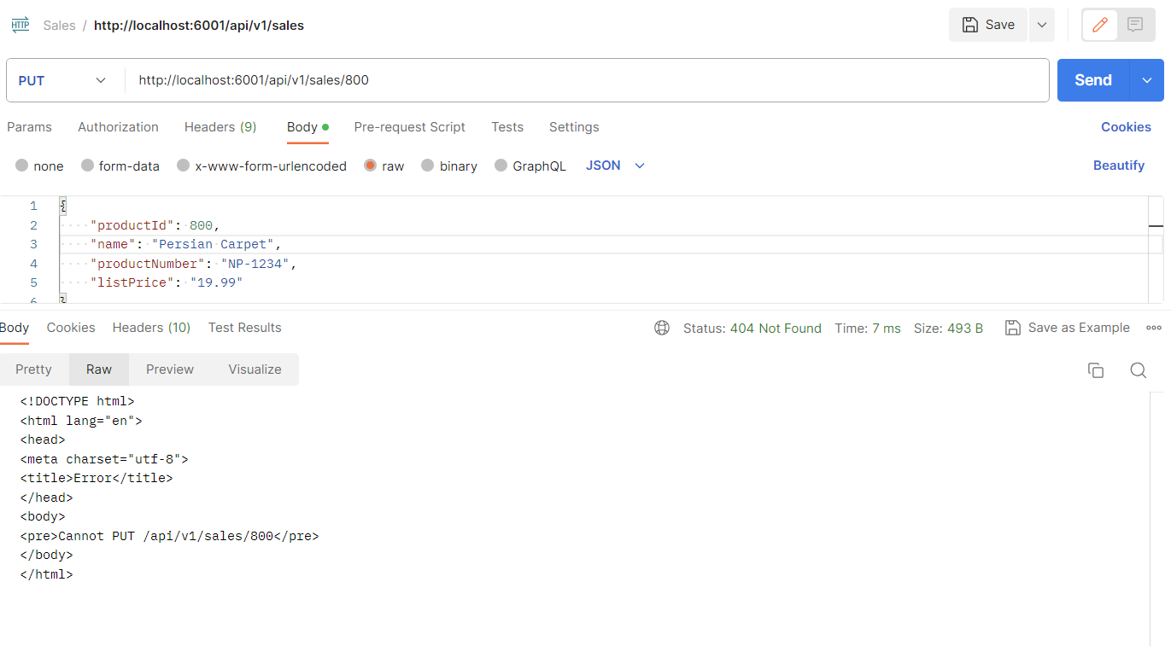

*Note.* Updated sales product by changing the name via PUT route. This is the response status since we do not have administrative access to AdventureWorks database to manipulate the data, the new product could not be added and, consequently, it could not be updated. From Personal VS code by Tahaylia Higgins, 2023.

*Note.* Query for product name containing ‘ML Road Frame - Red, 48 via GET /sales?name= according to the assignment and this is the response. From Personal VS code by Tahaylia Higgins, 2023.

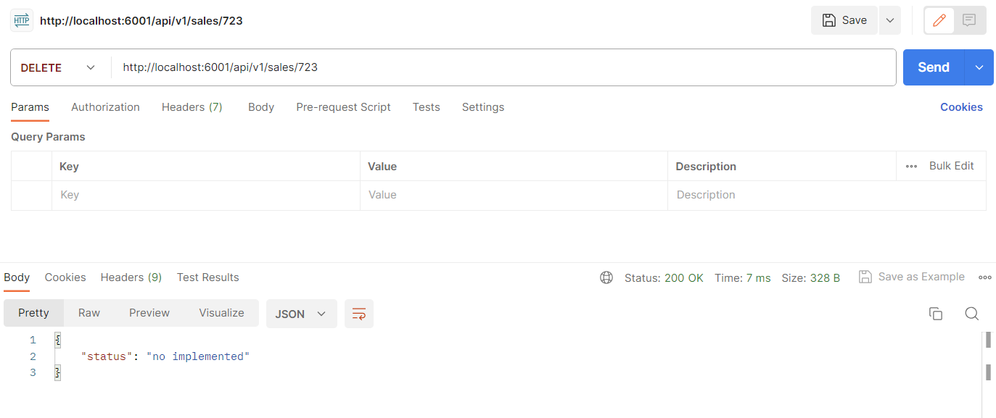

*Note.* Query to delete a sales product by id via DELETE route. This is the response status since we do not have administrative access to AdventureWorks database to manipulate the data, the product could not be deleted. From Personal VS code by Tahaylia Higgins, 2023.

Query Database

*Note.* SQL SELECT Statement to Query Data in four Tables. This is one of four tables. From Personal VS code by Tahaylia Higgins, 2023.

*Note.* SQL SELECT Statement to Query Data in four Tables. This is two of four tables. From Personal VS code by Tahaylia Higgins, 2023.

*Note.* SQL SELECT Statement to Query Data in four Tables. This is three of four tables. From Personal VS code by Tahaylia Higgins, 2023.

*Note.* SQL SELECT Statement to Query Data in four Tables. This is four of four tables. From Personal VS code by Tahaylia Higgins, 2023.

*Note.* Displaying SQL Statements that used to retrieve my Customer’s list. From Personal VS code by Tahaylia Higgins, 2023.

*Note.* Displaying the SQL statements used to JOIN Data in more than one table. From Personal VS code by Tahaylia Higgins, 2023.

*Note.* Displaying the SQL statements used to two tables. From Personal VS code by Tahaylia Higgins, 2023.